Overloading wrt autoboxing, widening & var args methods

Here we will discuss overloaded methods having Wrapper type args.

1. Case 1: Autoboxing vs Widening
   1. 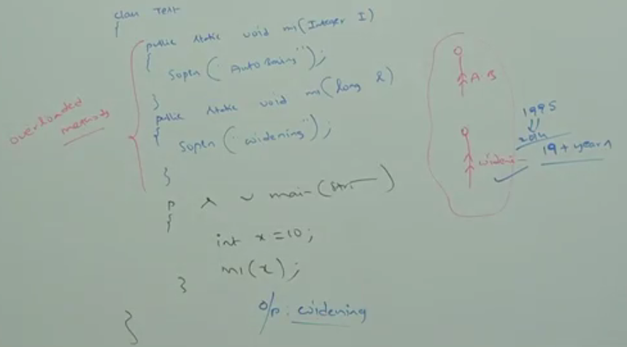  
      We have two methods overloaded. Out of them widening wins as widening is old concept.
   2. Case 2: Widening vs var args
      1. 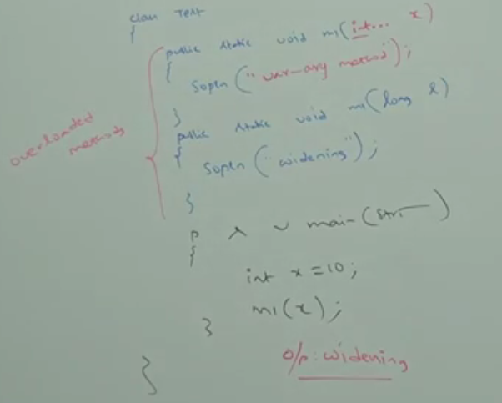  
         NOTE: out of widening and var args, widening wins as widening is old concept.
   3. Case 3: Autoboxing vs var args  
      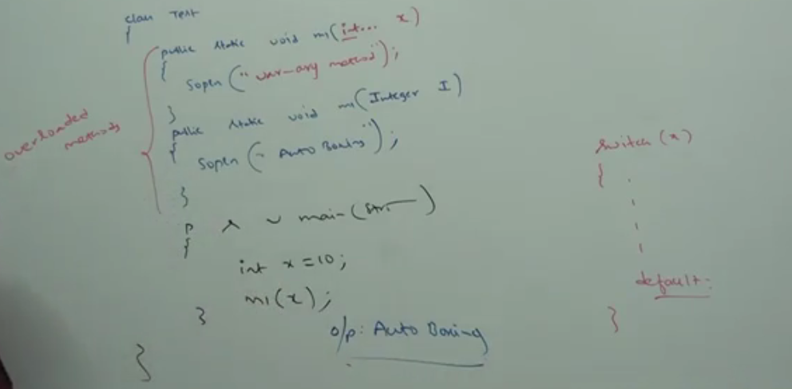Var args has least priority same as default case in switch statement.
   4. Case 4:   
      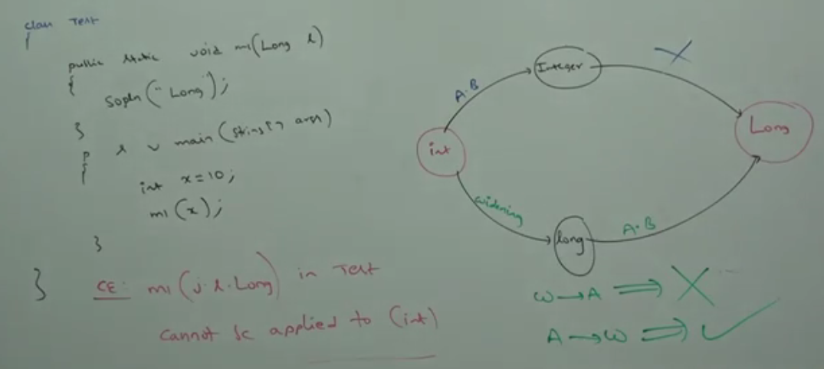
2. **\*NOTE**: While resolving overloaded methods, Compiler will always give precedence in the following order.
   1. widening
   2. Autoboxing
   3. Var args
3. 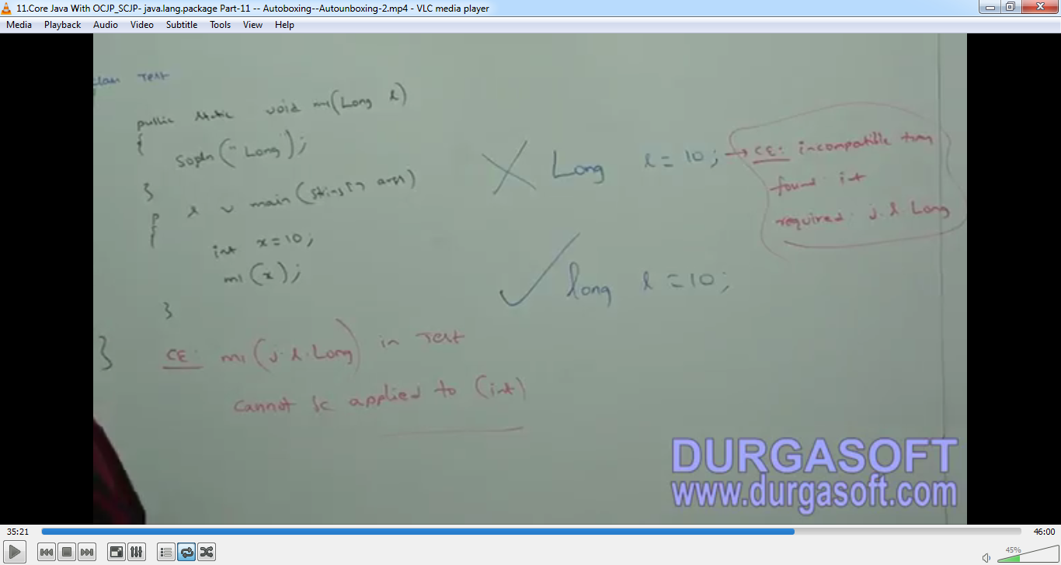
4. A 🡪 W Conversion (Autoboxing to Widening)  
   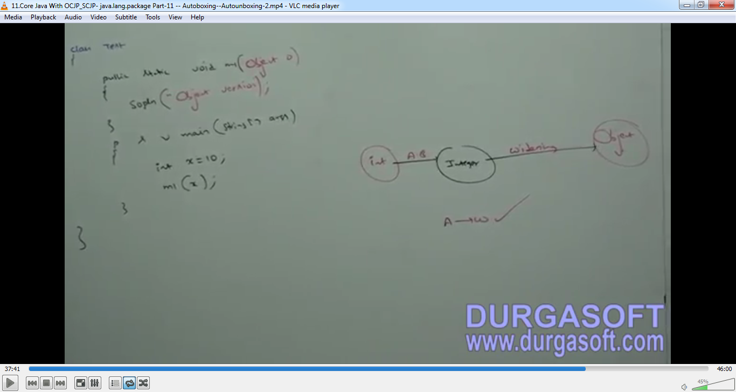
5. 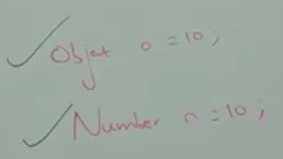

10 🡪 Integer 🡪 Number (As Integer is subtype of Number)

10 🡪 Integer 🡪 Object (Conversion Process)

1. **Exercise  
   